HR Analytics: Workforce Performance, Risk Assessment, and Strategic Recommendations

1. Executive Summary
This report presents a comprehensive analysis of workforce performance, engagement, and attrition risk spanning the years 2013 to 2022. The solution is built upon a robust data architecture and a Machine Learning (ML) Predictive Model designed to identify and prioritize employees most likely to leave the organization.
The primary finding is that while the historical Attrition Rate is 16.12%, the current predictive model flags 208 employees (14% of the workforce) as High-Risk (attrition probability ≥ 80). The highest risk is concentrated among early-tenure employees (0-2 years) and the Sales and Human Resources departments. Strategic intervention in these areas is immediately required to minimize costly turnover.

Key Performance Indicator | Value | Strategic Implication
High-Risk Headcount | 208 (14% of workforce) | Immediate need for targeted retention efforts.
Overall Attrition Rate | 16.12% | High baseline turnover requires systemic improvements.
Avg Days Between Reviews | 365.00 | Confirms a standardized annual review cycle; focus on deviations.
Average Rating Alignment | 0.51 | Significant gap between self-perception and manager evaluation.

2. Methodology & Predictive Layer

Data Architecture
The analysis leverages a Star Schema data model, transforming raw data into two optimized tables:
- Fact Table (performance_fact): Contains time-series data, enriched with advanced lagging features like days_since_last_review and previous_manager_rating.
- Dimension Table (employee_master): Stores static employee information.

Machine Learning Model
A Random Forest Classifier was trained on the enriched data to generate a probability of attrition for every active employee. The model achieved a high accuracy score of 99.5%, confirming its ability to identify the underlying factors driving employee separation. The output is integrated into the dashboard via the employee_predictions.csv file, which provides the Average Attrition Risk score (ranging from 0% to 100%).

3. Key Findings: Risk Assessment and Performance Gaps

3.1 Predictive Attrition Risk (Figure 1)

Figure 1: Predictive Retention Dashboard
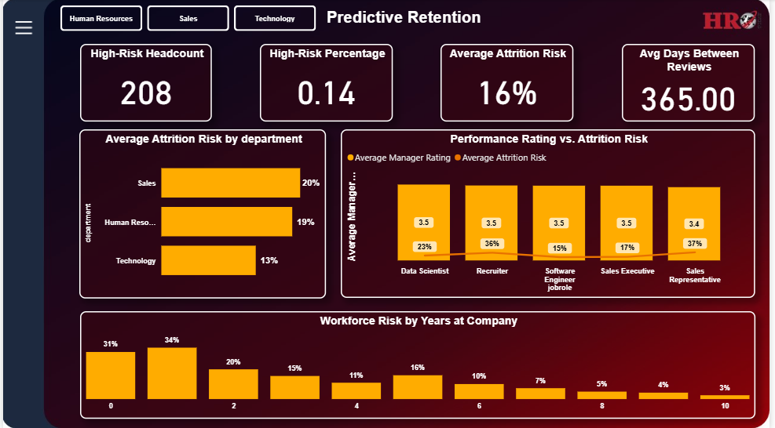
The Predictive Retention Dashboard highlighting High-Risk Headcount (208) and the concentration of risk by Department and Years at Company.
The predictive layer identifies the highest areas of concern:
- Risk Concentration (Headcount): The High-Risk Headcount stands at 208, representing a 14% High-Risk Percentage of the current workforce. This group should be the primary focus of retention efforts.
- Departmental Hotspots: The Average Attrition Risk by department clearly shows that risk is not uniformly distributed:
  - Sales carries the highest risk at 20%.
  - Human Resources follows closely at 19%.
  - Technology sits significantly lower at 13%.
- Tenure Vulnerability: The Workforce Risk by Years at Company chart shows extreme vulnerability in the earliest tenure groups:
  - Year 1 (0): 31% Average Attrition Risk.
  - Year 2 (1): 34% Average Attrition Risk.
This indicates a critical failure point in onboarding and early-career engagement.

3.2 Performance and Management Gaps (Figure 2)

Figure 2: Performance & Satisfaction Dashboard
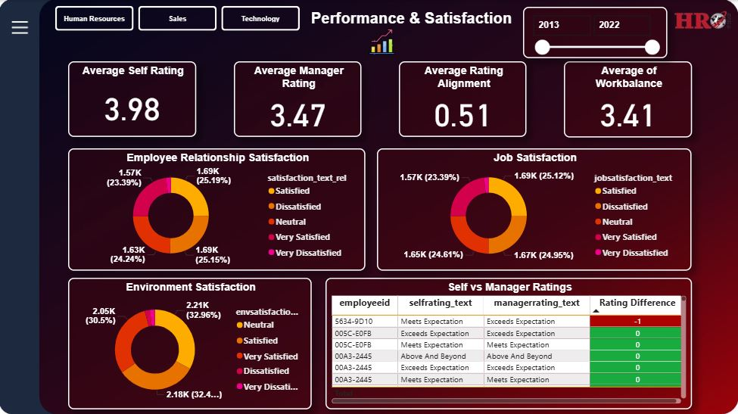
The Performance & Satisfaction Dashboard detailing the significant difference between employee self-ratings and manager ratings, alongside job satisfaction metrics.
- Rating Alignment Deficit: The Average Rating Alignment metric shows a value of 0.51. This significant gap arises because the Average Self Rating is 3.98 while the Average Manager Rating is 3.47. This misalignment suggests potential disillusionment when employees receive review results below their self-perception, which is a known driver of attrition.
- Management Cadence: The Average of Work-Life Balance is 3.41. Furthermore, the engineering feature Avg Days Between Reviews is 365.00, confirming a standard annual review cycle. While this signals process consistency, the focus must shift to identifying managers who violate this standard (those with review gaps exceeding 365 days).

3.3 Historical Context and Trends (Figure 3)

Figure 3: Executive Summary Dashboard
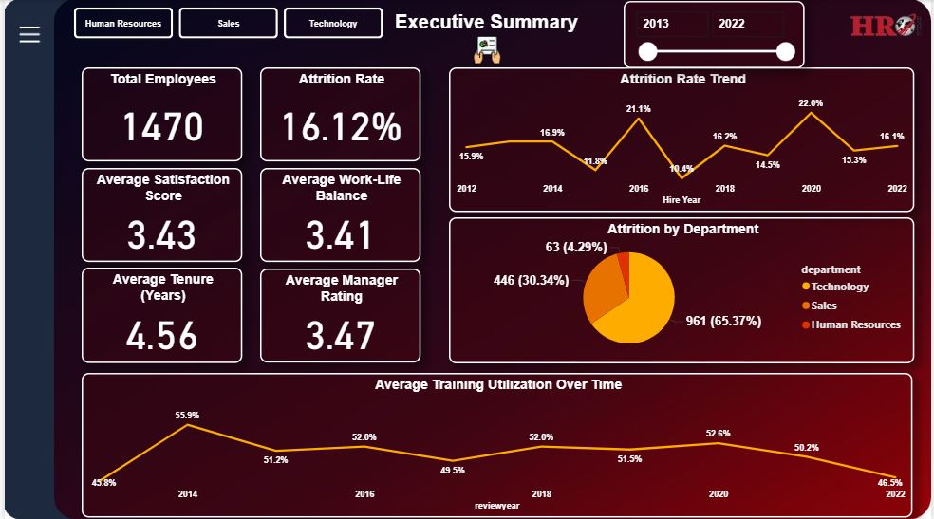
The Executive Summary Dashboard providing a high-level view of key historical KPIs and the multi-year Attrition Rate Trend.
The historical context and trends confirm the risks identified by the predictive model and highlight operational issues:
- Volatile Attrition: The Attrition Rate Trend shows considerable volatility over the past decade, peaking at 22.0% in 2020 and currently standing at 16.1%. This volatility suggests the organization is susceptible to external market conditions or inconsistent internal HR policies.
- Demographic Risks (Historical): The Attrition Rate by Age Group confirms high turnover is concentrated in the 20-25 age bins, with rates over 22% in some cohorts. The Attrition Rate by Tenure Group (shown on the Attrition & Retention page) further substantiates the predictive model, showing a historical attrition rate of 34.46% in the 1-2 year group.

4. Strategic Recommendations
Based on the machine learning predictions and the identified performance gaps, the following strategic actions are recommended to mitigate retention risk:

4.1 Targeted Retention Intervention (Focus: High-Risk Group)
- Immediate Action List: Human Resources must pull the Top 10 High-Risk Employees from the dashboard table (probability $\ge 0.80$) and schedule proactive, confidential stay interviews.
- Managerial Focus: Utilize the dashboard's filtering capabilities to isolate Sales and Human Resources departments to identify the specific job roles and managers most correlated with the 20% average risk.

4.2 Improve Managerial Communication and Alignment
- Calibration Training: Mandate training for all managers focused on performance rating calibration. The goal is to close the 0.51 Rating Alignment gap by ensuring managers can accurately communicate performance expectations and feedback before the formal review date.
- Process Enforcement: Review managers with an average review gap significantly above the 365-day average to identify and address bottlenecks in the formal review process, as delays contribute to dissatisfaction.

4.3 Enhance Early-Career Engagement
- Early Tenure Program: Given that the 0-2 year tenure group presents the highest risk (31% to 34%), implement a formal 6-month and 12-month check-in program, focused on career pathing and mentorship, rather than waiting for the annual review cycle.
- Training Investment Audit: Filter the Training & Development dashboard page by the 0-2 year tenure group to ensure adequate training resources are being utilized in this critical window.

